Ideation Phase
Brainstorm & Idea Prioritization Template

Date | 19 February 2026
Team ID | LTVIP2026TMIDS45121
Project Name | shopsmart: your digital grocery store experience
Maximum Marks | 4 Marks

Brainstorm & Idea Prioritization Template:

Step-1: Team Gathering, Collaboration and Select the Problem Statement
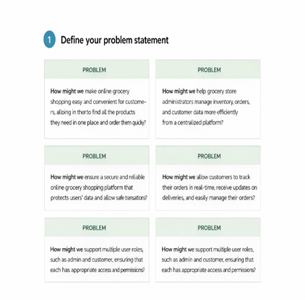

Step-2: Brainstorm, Idea Listing and Grouping
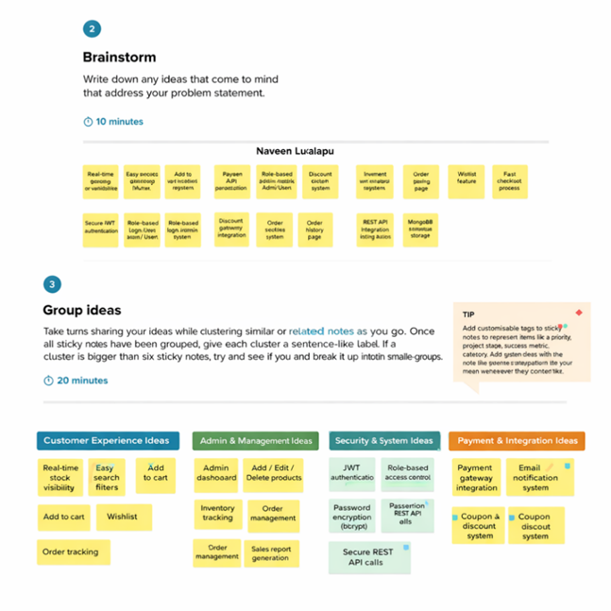

Step-3: Idea Prioritization
